**Switch controller:**

First we need to record the scripts then Place the recordings in the sampler controllers.

The Switch Controller acts like the Interleave Controller in that it runs one of the subordinate elements on each iteration, but rather than run them in sequence, the controller runs the element defined by the switch value.

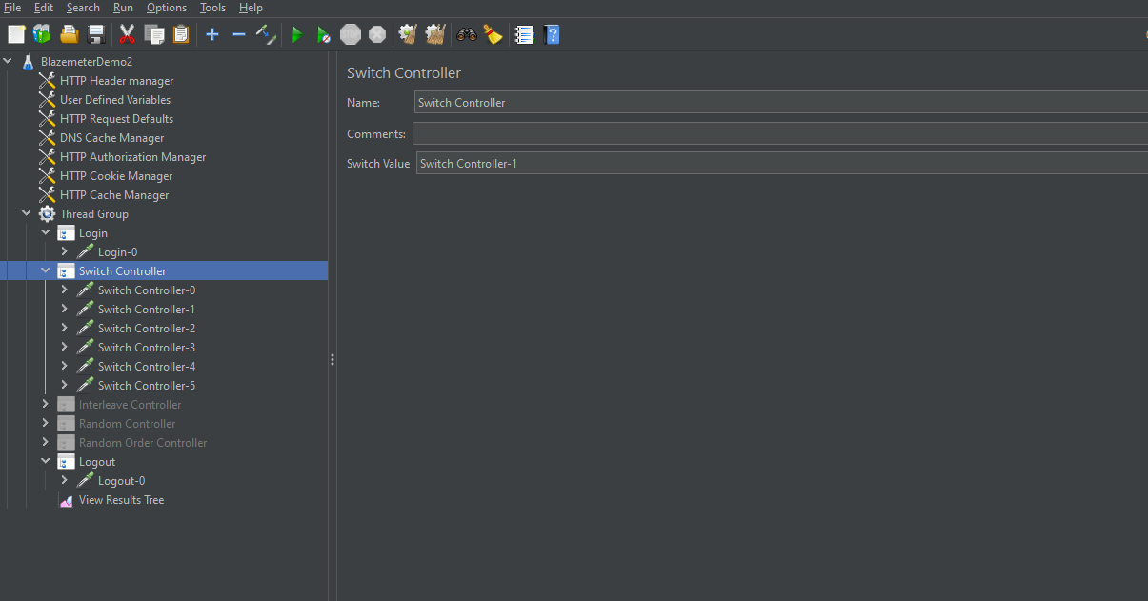

The above we can see that the we can provide the Switch value and the value we provide in the switch it will execute that test only.

The remaining tests will be skipped present under the switch controller.

The below we can see that I provide the switch value as” Switch Controller-1",and it will execute only that test and skip remaining tests.

